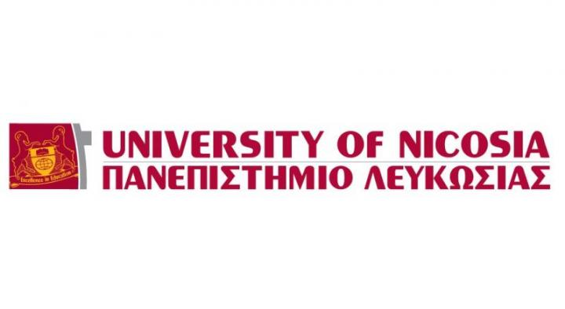

**ERASMUS PLACEMENT OFFER**

|  |  |
| --- | --- |
| **EMPLOYER INFORMATION** | |
| **Name of the Organization** | **UNIVERSITY OF NICOSIA** |
| **Address** | 46 Makedonitissas Ave. |
| **Postal Code** | 2414 |
| **City** | Nicosia, Cyprus |
| **P.O Box** | 24005 , 1700 Nicosia |
| **Telephone** | +35722841500 |
| **Fax** | +35722357481 |
| **Website** | <http://www.unic.ac.cy/> |
| **UNic at a Glance** | The University of Nicosia is an independent, co-educational, equal opportunity tertiary education institution, combining the best elements in western education, quality standards and an international philosophy. |

|  |  |
| --- | --- |
| **CONTACT DETAILS** | |
| **Contact Person** | Georgia Argyrou, Erasmus Assistant Officer |
| **Department/Function** | Erasmus Office |
| **Direct Telephone Number** | +35722841571/726/727/563 |
| **Direct Email Address** | argyrou.g@unic.ac.cy |

|  |  |
| --- | --- |
| **PLACEMENT INFORMATION** | |
| **Department/Function** | Erasmus Office/ Student`s Affairs |
| **Description of Activities** | **Graphic design** input is required for a huge variety of products and activities, including:  - leaflets, posters, magazines, newsletters , advertising , exhibition, displays  -Prepare promotional materials for Erasmus and also for Student`s Affairs |
| **Skills and Personal Qualities** | -creative flair  -a strong visual sense  -originality  -strong computer skills  -confidence, to present and explain ideas  -the ability to balance work on several projects at a time  -flexibility  -very good organizational skills |
| **Duration** | Minimum 6 months |
| **Working Hours** | Approximately 20 Hours per week |
| **Help with finding Accommodation** | YES ( we can provide a list with possible flats or rooms for rent) |

|  |  |  |
| --- | --- | --- |
| **REQIUREMENTS** | | |
| **Excellent English language skills** | Candidate must be able to communicate in English. Since all the tasks will be delivered in English.  *( Provide us with relevant document if any)* | |
| **Portfolio** | Send us your existing Portfolio | |
| **Graphic design student or Graduate** | Graduate Student or 4th year Bachelor student  *( Provide us with relevant document )* | |
| **Require Documents** | -CV  -Motivational Letter  -Portfolio | - Copy of your English Language Document  -Copy of your Bachelor or any other Diploma |
| ***Please send your relevant document in this email:*** [***argyrou.g@unic.ac.cy***](mailto:argyrou.g@unic.ac.cy)  ***Deadline: 15th of October 2014*** | | |