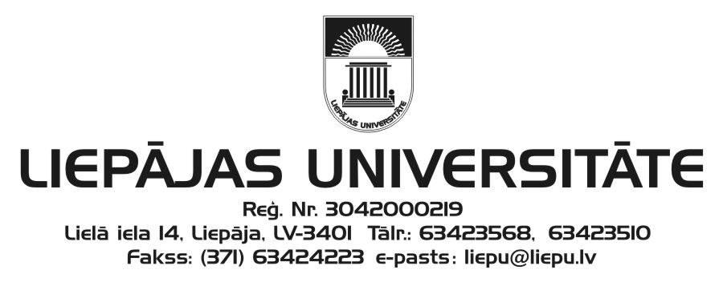

Liepāja University
Faculty of Humanities and Arts
and
Kurzeme Institute of Humanities
invite you to participate in

the 23rd International Scientific Conference
“The Word: Aspects of Research”
which will be held at Liepāja University
29–30 November 2018

The workshop on diachronic and areal linguistics is dedicated to the 90th anniversaries of birth of
Professor Antoņina Reķēna and linguist Silvija Raģe.

Please submit your application to the Scientific and Organising Committee on-line (https://vards.liepu.lv) from 10 September 2018 by 15 October 2018.
The acceptance letter will be sent by 29 October 2018.

Working languages: Latvian, Lithuanian, English, German, and Russian.

Conference fee: EUR 65.00
Please transfer your participant fee by 7 November 2018 to the following account:
Liepāja University
Lielā iela 14, Liepāja, LV-3401
Reg. No.: LV90000036859
Account: LV45TREL9150190000000
Indicate: your first name, surname
Details: conference “The Word: Aspects of Research” participant fee ECC – 21499

A conference proceedings “The Word: Aspects of Research” (ISSN 1407–4737) will be published on the presented reports in the conference. Indexed by EBSCO.

Dr. Philol. Ieva Ozola, Head of the Scientific Committee
Dr. Philol. Linda Lauze, Head of the Organising Committee

Address of the Scientific and Organising Committee:
Liepāja University
Faculty of Humanities and Arts
Kūrmājas pr. 13
Liepāja, LV-3401
Dr. Philol. Anita Helviga, Secretary
Phone: (+371) 63483781
e-mail: balti@liepu.lv
Information on accommodation in Liepaja is available on http://liepaja.travel/lv/naksnot/pilseta/viesnicas/

