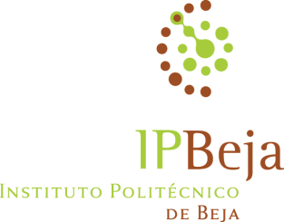

Lecturer: Prof. Maria Teresa Santos
Place: Liepaja University
Dates: 24 to 28th of November 2014
Course Title: The challenges of Inclusive Education at school and class level
Programme Contents | Day/  Estimated time
I - Inclusion of all in school: principles, philosophy, challenges for school teachers and head-teachers  1. From Segregation to Inclusion: main milestones  2. Integration versus Inclusion  3. Inclusion in schools  3.1. Leadership: the role of head-teachers  3.2. Building inclusive environments: the Index for Inclusion as a tool for practice  II- Pedagogical differentiation in class to accommodate the diversity of pupils  1. Defining concepts and theoretical framework  2. Strategies for differentiating instruction  3. Planning pedagogical differentiation in class  III- Participants’ assessment and course evaluation | 24/11/14  10:00 – Room 227  12:00 – Room 227  25/11/14  12:00 – Room 327  14:00 – Room 327  26/11/14  08:30 – Room 303  10:00 – Room 303  27/11/14  10:00 – Room 438  12:00 – Room 438  14:00 – Room 438  28/11/14  12:00 – Room 303
Methodologies: these will be mainly active learning situations where participants are called to be involved in texts/videos analysis, reflection, problem solving either individually or in small and big group. Some information will be also delivered by teacher.
Materials:
Provided by the lecturer: texts/videos
Provided by the university: computer/projector/ copies of texts/ sheets of paper A3 / coloured pens.

