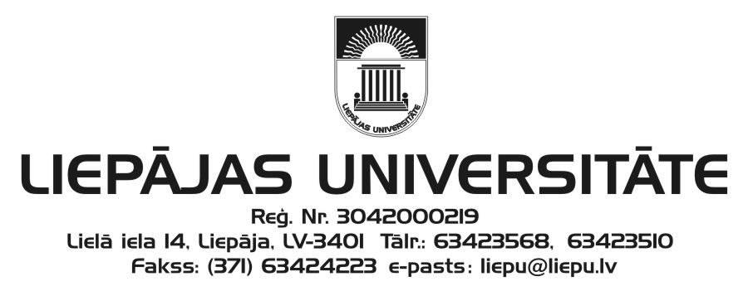
Liepāja University
Faculty of Humanities and Arts
and
Kurzeme Institute of Humanities
invite you to participate in

the 20th International Scientific Conference
“The Word: Aspects of Research”

which will be held at Liepāja University
3–4 December 2015

Please submit your application (see the attached form) to the Scientific and Organising Committee (e-mail: balti@liepu.lv) by 14 October 2015.
The acceptance letter will be sent by 26 October 2015.

Working languages: Latvian, Lithuanian, English, German, and Russian.

Conference fee: EUR 65.00
Please transfer your participant fee by 9 November 2015 to the following account:
Liepāja University
Lielā iela 14, Liepāja, LV-3401
Reg. No.: LV90000036859
Account: LV45TREL9150190000000
Indicate: your first name, surname
Details: conference “The Word: Aspects of Research” participant fee
ECC – 21499

Dr. Philol. Ieva Ozola, Head of the Scientific Committee
Dr. Philol. Linda Lauze, Head of the Organising Committee

Address of the Scientific and Organising Committee:
Liepāja University
Faculty of Humanities and Arts
Kūrmājas pr. 13
Liepāja, LV-3401
Dr. Philol. Anita Helviga, Secretary
Phone: (+371) 63483781
e-mail: balti@liepu.lv

20th International Scientific Conference
“The Word: Aspects of Research”
3–4 December 2015
Liepāja
APPLICATION FORM

First name, surname
Scientific
(academic) degree
Current doctoral studies (institution, programme)
Job, position
E-mail
Phone
Postal address
Theme of the speech (title)
Abstract

Presentation equipment required

_______
(date)

