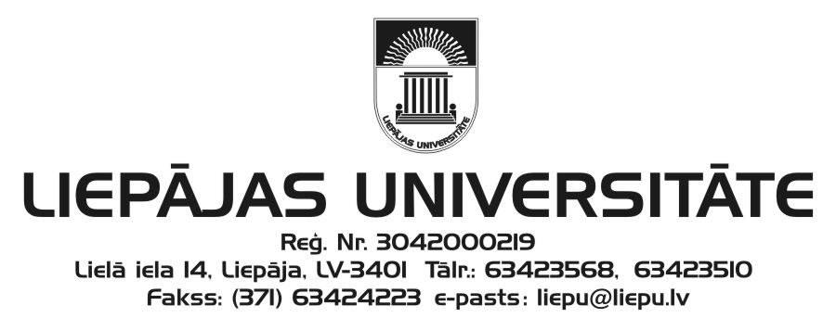
Liepāja University
Faculty of Humanities and Arts
and
Kurzeme Institute of Humanities
invite you to participate in

the 19th International Scientific Conference
“The Word: Aspects of Research”

which will be held at Liepāja University
27–28 November 2014

Please submit your application (see the attached form) to the Scientific and Organising Committee (e-mail: balti@liepu.lv) by 14 October 2014. The acceptance letter will be sent by 31 October 2014.
Working languages: Latvian, Lithuanian, English, German, and Russian.
Conference fee: EUR 65.00
Please transfer your participant fee by 7 November 2014 to the following account:
Liepāja University
Lielā iela 14, Liepāja, LV-3401
Reg. No.: LV90000036859
Account: LV45TREL9150190000000
Indicate: your first name, surname
Details: conference “The Word: Aspects of Research” participant fee
ECC – 21499

The 19th conference “The Word: Aspects of Research” is dedicated to Liepāja University 60th Anniversary.

Dr. Philol. Ieva Ozola, Head of the Scientific Committee
Dr. Philol. Linda Lauze, Head of the Organising Committee
Address of the Scientific and Organising Committee:
Liepāja University
Faculty of Humanities and Arts
Kūrmājas pr. 13
Liepāja, LV-3401
Mg. Philol. Anita Helviga, Secretary
Phone: (+371) 63483781
e-mail: balti@liepu.lv

19th International Scientific Conference
“The Word: Aspects of Research”
27–28 November 2014
Liepāja
APPLICATION FORM

First name, surname
Scientific
(academic) degree
Current doctoral studies (institution, programme)
Job, position
E-mail
Phone
Postal address
Theme of the speech (title)
Abstract

Presentation equipment required

_______
(date)

